SQL PROJECT
By- ABHIJITH SURESH

PRODUCTS TABLE

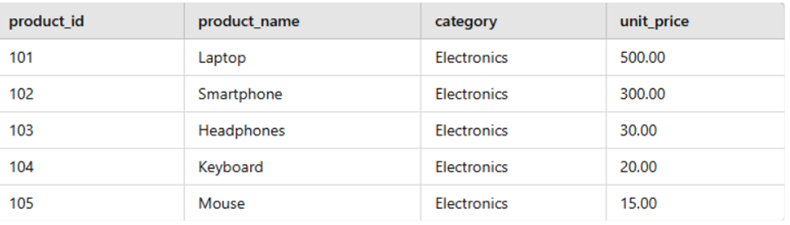

SALES TABLE

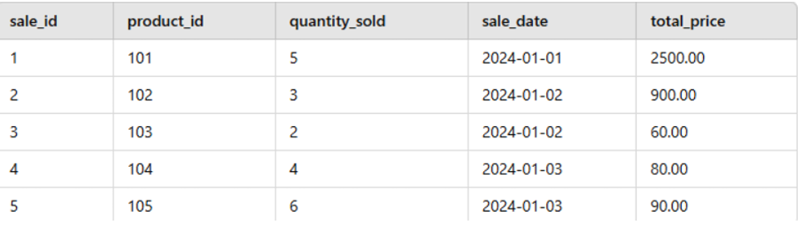

Query 1- List the Top 3 Products by Revenue Contribution Percentage
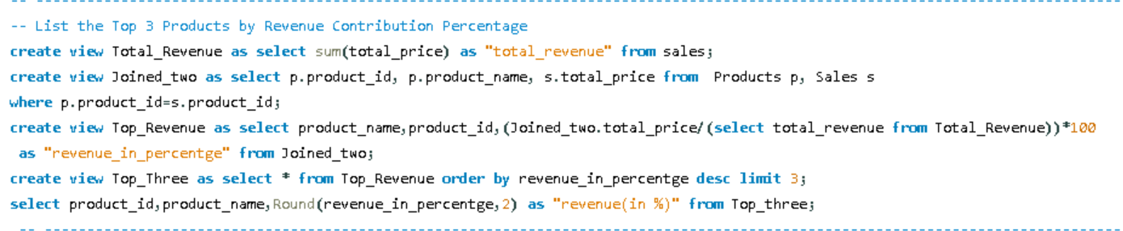
OUTPUT
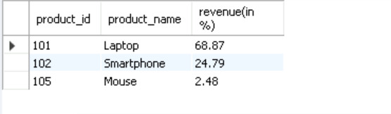

Query 2- Write a query to create a view named Total_Sales that displays the total sales amount for each product along with their names and categories

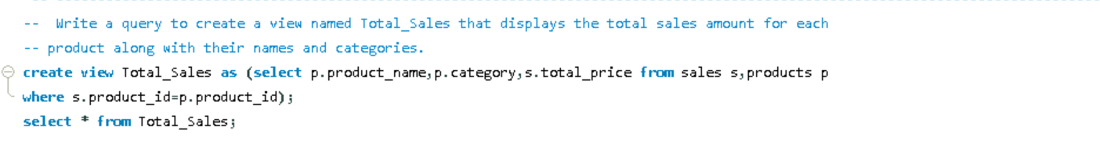
OUTPUT
